Mid Body Laser Designated Guidance Section Design

A Semi Active Laser Guided Missile uses a bi-static or on board designator to illuminate a target with a laser spot. The spot has a known pulse rate frequency and the pulse intervals are modulated with a guidance section. The Mid body guidance section receives reflected energy from the spot, which determines the azimuth to target and calculates a guidance error in azimuth and elevation. The azimuth and elevation error are defined as the angle θ_{a} and θ_{e}, shown in Figure 1.
Missile Elevation θ_{e}
Missile Azimuth θ_{a}
Received Energy
Missile Fin in
Elevation Position
Missile Fin in
Azimuth Position
θ_{a}
θ_{e}
Missile Rotational
Direction θ
Figure 1 – Missile Azimuth and Elevation

The angle error is measured by the servo system of Figure 2.

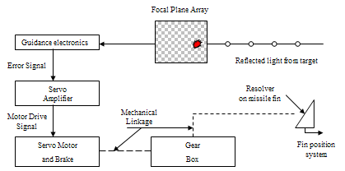
Figure 2 – Missile Servo

The optical seeker measures the angle from the azimuth (or elevation) axis to the target position. The guidance electronics produce an error signal proportional to the angular displacement between the fin position and the angle to the received light beam. The servo motor rotates the fin. The resolver measures the fin rotational position. To save weight the system only has 1 set of movable fins, so the servos must be multiplexed while the missile spins.

The block diagram representation, below, of the servo system is illustrated in Figure 3. The transfer functions of the guidance electronics and the servo amplifier are 300 millivolts per arc second and 30 volts per volt, respectively. The transfer function of the servo motor and the brake is:

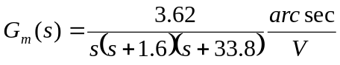

The reduction gear ratio is 1/302.7. The output angle θ₅ fin is proportional to the sine of its input angle θ₄. Since the fin resolver is designed to measure misalignment angles no greater than 900 arc seconds, a linear approximation can be made. Also θ₄ and θ₅ are in the same units,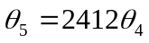.

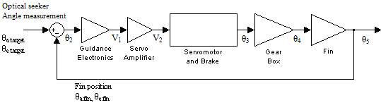
Figure 3 – Block Diagram of the Fin Servo System
The system response to a unit step in misalignment angle is to have less than 20% overshoot and is to settle to within 2% of its final value in 0.6 seconds or less. The velocity error constant is relatively unimportant since the misalignment is unlikely to change during its measurement. Please determine if the present system meets the specifications. If it doesn’t, determine what is needed to make the system meet these requirements. To do this verify the overshoot and settling time by applying a unit step input to the closed-loop system and determine its response.

Additional Information Required
What rate must the missile spin at and the designator pulse rate frequency be set to? How much can the missile rotate during guidance corrections to minimize cross coupling? Please discuss your opinion of the missile settling time. What effect does it have on the missiles rotational rate?

Deliverables
- 15 Minute Group Presentation
  - Everyone must present a technical portion of results
- All calculations, figures, and models typed (No handwriting accepted)
  - One Per Group
  - Not a formal report, just all calculations and so forth nicely organized needed for grading purposes.
  - Any M-files should be delivered as well for grading purposes.

